Module 4 Summary – Jacob Booth 221530207

Response to feedback

No feedback yet from module 3, but I’ve tightened my new workflow for timeliness, with the additional aim of addressing concepts more to-the-point and emphasising underlying links. I’ve focused on adapting my writing style to align with standards for mathematical report writing, just hoping as always that I haven’t written too summarily or briefly for anything that needs more focus. Other than that, I really enjoyed this module.

Module Learning Objectives
I certify that I achieved the following learning objectives for the module:
- Calculate determinants using the cofactor expansion
- Use properties of determinants (Theorem 3.1.2) to calculate determinants
- Calculate matrix inverses using adj A and det(A)
- Identify the inverse of an orthogonal matrix
- Perform LU-factorisation on a matrix and use this to solve systems of linear equations

Key Definitions and Theorems
The Cofactor Expansion
Textbook Ref | Theorem/Definition statement | Learning Notes
Determinant Calculation  for a 3×3 matrix | For a 3×3 matrix, A – the determinant is given by | Draws on the products of diagonals  Use either the shortcut formula with Sarrus’ rule or expansion by minors
Definition 3.1 Cofactors of a matrix | Assume that determinants of (n − 1) × (n − 1) matrices have been defined. Given the n × n matrix A, let  A_{ij} denote the (n − 1) × (n − 1) matrix obtained from A by deleting row i and column j. Then the (i, j)-cofactor c_{ij}(A) is the scalar defined by  c_{ij}(A) = (−1) ^{i+j} det (A_{ij})  Here (−1) ^{i+j} is called the sign of the (i, j)-position. | Dissecting sub-matrices from larger ones, carrying the idea of composition  Convenient method, just requires reference to the formula
Definition 3.2  Cofactor expansion of a matrix | Assume that determinants of (n − 1) × (n − 1) matrices have been defined. If A = [a_{ij}] is n×n define,  det A = a₁₁c₁₁(A) + a₁₂c₁₂(A) +···+ a_{1n}c_{1n}(A)  This is called the cofactor expansion of det A along row 1. | Defining the determinant from smaller pieces, recursively defining smaller matrix dets to define the det of A
Theorem 3.1.2 Determinant properties | Let A denote an n × n matrix.  - If A has a row or column of zeros, detA=0.  - If two distinct rows (or columns) of A are interchanged, the determinant of the resulting matrix is − det A.  - If a row (or column) of A is multiplied by a constant u, the determinant of the resulting matrix is u( det A).  - If two distinct rows (or columns) of A are identical, det A = 0.  - If a multiple of one row of A is added to a different row (or if a multiple of a column is added to a different column), the determinant of the resulting matrix is det A. | Unique behaviour of det, proportional scaling but adding one row to another doesn’t change det  Reduces the logic down to 5 constraints on the determinant, helpful for quick interpretation

Determinants and matrix inverses
Textbook Ref | Theorem/Definition statement | Notes
Theorem 3.2.1 Product theorem | If A and B are n×n matrices, then  det(AB) = det A det B. | Matrix product det or det of matrix product, both are the same
Theorem 3.2.2 Det relationship to inverse | An n×n matrix A is invertible if and only if det A  0. When it is invertible, we have, | Any matrix with a non-zero det is invertible
Theorem 3.2.3 Det of transpose | If A is any square matrix, det (A^{T}) = det A | Det persists across transposition
Theorem 3.2.4 Adjugate formula | If A is any square matrix, then  A(adj A) = (det A) I = (adj A) A  In particular, if det A  0, the inverse of A is given by | Multiplying A with adj(A) gives (det(A))I  Leading into the inverse formula

LU Factorisation
Textbook Ref | Theorem/Definition statement | Notes
Theorem 2.7.1 LU Theorem | If A can be lower reduced to a row-echelon matrix U, then  A=LU  where L is lower triangular and invertible and U is upper triangular and row-echelon. | Without row swaps, if matrix A can be reduced then it factors into L and U composition
LU Algorithm | Let A be an m × n matrix of rank r, and suppose that A can be lower reduced to a row-echelon matrix U . Then A = LU where the lower triangular, invertible matrix L is constructed as follows:  - If A=0, take L= I_{m} and U = 0.  - If A0, write A₁=A and let c₁ be the leading column of A₁. Use c₁ to create the first leading 1 and create zeros below it (using lower reduction). When this is completed, let A₂ denote the matrix consisting of rows 2 to m of the matrix just created.  - If A₂ 0, let c₂ be the leading column of A₂ and repeat Step 2 on A₂ to create A₃.  - Continue in this way until U is reached, where all rows below the last leading 1 consist of zeros. This will happen after r steps.  - Create L by placing c₁, c₂, ..., c_{r} at the bottom of the first r columns of I_{m}. | For each multiplier in elimination, build L from each m, recording scalar pivots in L and reduced A in U

Summarising your understanding:

Module 4 ties together theory from Gaussian Elimination, matrix multiplication, and LU Theorem, outlining the behaviour of determinants in the scope of cofactors and compositions. The module underpins cofactor expansion as a foundation for determinant calculation, and compares the preservation/scaling properties of each elementary operation. The matrix adjugate and transposition are reintroduced to highlight the behaviour of the determinant across different forms of a matrix.

4.1 The Cofactor Expansion
Determinant Calculation for a 3x3 matrix
Based on 3x3 square matrices, the determinant can be calculated via the explicit formula det(A) = aei + bfg + cdh - ceg - afh – bdi, or by cofactor expansion, breaking A down into smaller parts and building the determinant from sub-matrix determinant results.
Definition 3.1 Cofactors of a matrix
Referred to as a signed determinant of position (i, j), finding the cofactor of a row i, column j entry involves removing the row and column before taking the determinant from the smaller remaining matrix. Multiplying the result by (-1)^{i+j} adjusts the +/- sign for the final result.
Definition 3.2 Cofactor expansion of a matrix
Building from cofactors as signed determinants in Definition 3.1, cofactor expansion is used for calculating the determinant of a matrix via its cofactors, as opposed to the formula stated in determinant calculation for 3x3 matrices. This involves multiplying each row/column entry by its cofactor (D3.1), giving the determinant.
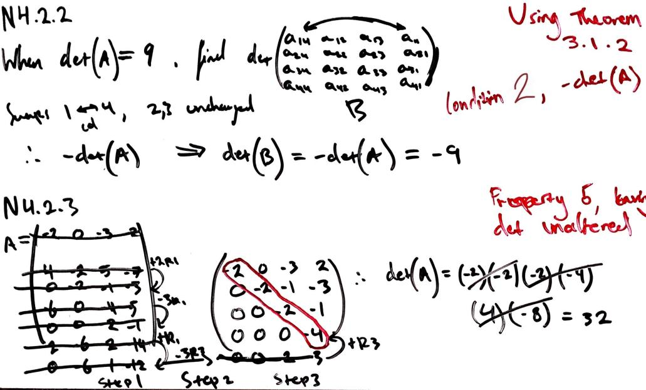
Theorem 3.1.2 Properties of determinants
Drawing on structural behaviour determined by Definitions 3.1, 3.2, this theorem outlines the defining characteristics of determinants, dictating whether the determinant will be 0 or nonzero, and whether it will be a positive or negative number. Scalar row operations can scale the determinant while adding a multiple of one row to another doesn’t change it at all. Looking specifically at condition 4, det(A) becomes 0 due to cofactor expansion along that row, cancelling out with its opposite corresponding (-1)^{i+j} contribution (D3.1) when cofactors are summed (D3.2). This indicates a recursive relationship between D3.1, 3.2, where each determinant requires cofactor expansion until the base case (smallest component) is reached.
A worked example of applying rule 2 of Theorem 3.1.2 to simplify the calculation of a larger determinant, followed by an example applying rule 5 to persist the determinant through elimination (no scaling) for simplicity.
4.2 Determinants and Matrix Inverses
Theorem 3.2.1 Product Theorem
The base theorem for composition with determinants (Sub-module 4.1), multiplying two square matrices and taking their determinant will be the same as taking the determinant of each and multiplying them, both are equal. Determinants are subject to predictable behaviour through multiplication, and are convenient for linear analysis. Product Theorem underpins behaviour outlined by Theorem 3.2.2 → 3.2.4 when exposing determinants of square matrices, their inverses, transpositions, and adjugates, to determinant calculations.
Theorem 3.2.2 Determinant relationship to inverse
The logic applied to Product Theorem 3.2.1 infers the inverse for a matrix A will always exist given that the determinant isn’t zero. A zero determinant “flattens” the matrix, collapsing it in a way that can’t be reversed to retrieve the original information, it’s all lost during cofactor expansion as it reduces to 0. This is consistent with
conditions outlined by Theorem 3.1.2, for example:
2) rows or columns swapped → det(A) = - det(A),
4) matching cols or rows → det(A) = 0.
A non-zero determinant indicates full rank and the existence of an inverse.
Theorem 3.2.3 Determinant of transpose
Flipping the matrix over its diagonal won’t alter the determinant. Persistence over transposition demonstrates that row-based and column-based operations are symmetric in regards to determinants.
The transpose is equivalent to the inverse for an orthogonal matrix A. The determinant of a transposed orthogonal matrix is therefore the same as the determinant of the inverse orthogonal matrix, both of which are equal to the determinant of the original system.
Theorem 3.2.4 Adjugate Formula
Applying Definitions 3.1, 3.2 for building the adjugate from determinants and cofactors, the adjugate formula forms adj(A) by transposing the cofactor matrix of A. This depends on cofactor expansion being consistent through transposition of A, as outlined by Theorem 3.2.3.

Cramer’s Rule is a method for solving a linear system Ax = b, given det(A) is a non-zero value (T3.2.2) and the coefficient matrix is square. For each x_{i} in the system, replace the column i of A with the constant vector b, giving an intermediate matrix A_{i.} This gives the solution
x_{i} = det(A_{i}) / det(A). Cramer’s rule draws on the behaviour established by the adjugate formula (T 3.2.4). The solution for x is inverse-A multiplied by constant vector b, which is the same as (1/det(A)) * adj(A) * b. Each component draws on cofactor expansion with a modified matrix to establish an explicit formula for each variable.

4.3 LU Factorisation
Theorem 2.7.1 LU Theorem
Drawing on the same underlying logic for cofactor expansion (D3.2) without applying it explicitly, LU Theorem implies that given a matrix A can be reduced to row-echelon form without using any row swaps, A can be expressed as a matrix product composed of two smaller matrices, L and U. L is an invertible m*m matrix that holds the lower-triangular matrix of only non-zero values below the diagonal, corresponding to row op scalars. U is an upper-triangular m*n matrix in row-echelon form, denoting the reduced A. Given the decomposition of A, into row op scalars L, and the row-echelon matrix U, the composition A = LU holds true. Consistent with Theorem 3.1.2 property 5, avoiding any row/col swaps doesn’t alter the determinant.
LU Algorithm
Reducing A to row-echelon form through Gaussian Elimination, record the scalars used for elimination below the pivot into L, using the corresponding identity matrix as the foundation. The resulting U matrix is the same as A after elimination. This establishes the step-by-step method for factorising a matrix A into LU. LU Algorithm relies on the determinant behaviours outlined by Theorems 3.1.2, 3.2.1, demonstrating:
- Determinant consistency across row addition
- The product using determinants of matrices is consistent with the single determinant of a matrix product.

LU factorisation can be applied to full-rank square matrices, so long as they can be reduced to an upper-triangular without any row saps. LU Factorisation decomposes a square matrix A into the product of a lower-triangular matrix L and upper-triangular matrix U, expressing A as a factor of LU. This simplifies the problem space for solving Ax = b by reducing the matrix A into two smaller triangular systems, easier for solving. Additionally, passing in any constant vector b to solve for new solutions can be done with the same L and U matrices, speeding up solving for different constant term sets.

Module 4 encapsulates the recursive nature of determinant calculations, the relationships between determinant consistency and elementary row operations, and the behaviour of the determinant across different factorisations. The determinant provides a convenient metric for analysing a system’s properties and characteristics, like scaling behaviour, rank, etc,. LU factorisation ties this all together into a single workflow, demonstrating the efficient nature of solving linear systems as a composition of simpler parts. Respecting the constraints defined in this module, larger systems can be broken down without altering their defining properties, making solving and analysis easier and more efficient going forward.

Reflecting on the content
I found this module more intuitive than it initially appeared. I received a hit of nostalgia performing cofactor expansion and 3x3 determinant calculation, methods I’d seen and used in past classes without establishing the link until I was solving the problems. This was helpful and encouraging. I can also relate to the necessity of these concepts as a problem-solver from a computer science background. Breaking down large problems into meaningful, functional components forms the backbone of robust software engineering, in addition to the key module concepts being directly applicable to linear data analysis and software speedup. Overall, a very enjoyable unit that simplifies all the granular processes we’ve been working with weeks 1 – 4.

References

Summary, notes
[1] J. Chasnov, “LU Decomposition,” Applied Linear Algebra and Differential Equations, LibreTexts, [Online].
Available: https://math.libretexts.org/Bookshelves/Differential_Equations/Applied_Linear_Algebra_and_Differential_Equations_(Chasnov)/02:_II._Linear_Algebra/02:_Systems_of_Linear_Equations/2.05:_LU_Decomposition.
[Accessed: 05-Aug-2025].

[2] GeeksforGeeks, “LU Decomposition," Engineering Mathematics [Online].
Available: https://www.geeksforgeeks.org/engineering-mathematics/l-u-decomposition-system-linear-equations/.
[Accessed: 05-Aug-2025].

[3] D. Margalit & J. Rabinoff, “Cramer’s Rule and Adjugates,” Irvine Valley College, LibreTexts, [Online].
Available: https://math.libretexts.org/Courses/Irvine_Valley_College/Math_26%3A_Introduction_to_Linear_Algebra/02%3A_Linear_Transformations_and_Matrix_Algebra/2.06%3A_Cofactor_Expansions/2.6.02%3A_Cramer's_Rule_and_Adjugates.
[Accessed: 03-Aug-2025].

[4] D. Margalit & J. Rabinoff, “Cofactor Expansions,” Georgia Institute of Technology, LibreTexts, [Online].
Available: https://math.libretexts.org/Bookshelves/Linear_Algebra/Interactive_Linear_Algebra_(Margalit_and_Rabinoff)/04%3A_Determinants/4.02%3A_Cofactor_Expansions.
[Accessed: 03-Aug-2025].

Verification
[5] Incpt.Mobis, “Calculator Infinity,” App Store. [Online].
Available: https://apps.apple.com/us/app/calculator/id458535809.

